Stem cells show promise for stroke in pilot study
by Sam Wong08 August 2014
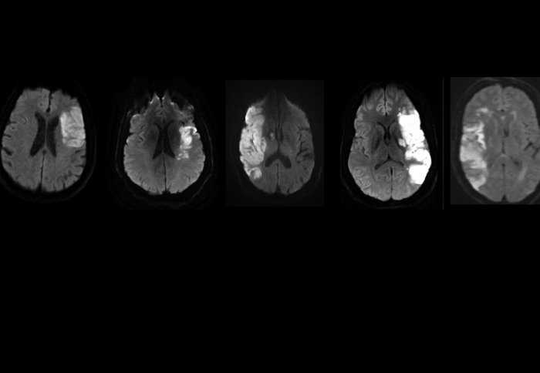
MRI scans showing brain damage in the stroke patients
before treatment. Source: Stem Cells Translational
Medicine.
A stroke therapy using stem cells extracted from patients' bone marrow has shown promising results in the first trial of its kind in humans.
Five patients received the treatment in a pilot study conducted by doctors at Imperial College Healthcare NHS Trust and scientists at Imperial College London.
The therapy was found to be safe, and all the patients showed improvements in clinical measures of disability.
The findings are published in the journal Stem Cells Translational Medicine. It is the first UK human trial of a stem cell treatment for acute stroke to be published.
The therapy uses a type of cell called CD34+ cells, a set of stem cells in the bone marrow that give rise to blood cells and blood vessel lining cells. Previous research has shown that treatment using these cells can significantly improve recovery from stroke in animals. Rather than developing into brain cells themselves, the cells are thought to release chemicals that trigger the growth of new brain tissue and new blood vessels in the area damaged by stroke.
Our aim is to develop a drug, based on the factors secreted by stem cells, that could be stored in the hospital pharmacy so that it is administered to the patient immediately following the diagnosis of stroke in the emergency room.
– Professor Nagy Habib
Department of Surgery and Cancer
The patients were treated within seven days of a severe stroke, in contrast to several other stem cell trials, most of which have treated patients after six months or later. The Imperial researchers believe early treatment may improve the chances of a better recovery.
A bone marrow sample was taken from each patient. The CD34+ cells were isolated from the sample and then infused into an artery that supplies the brain. No previous trial has selectively used CD34+ cells, so early after the stroke, until now.
Although the trial was mainly designed to assess the safety and tolerability of the treatment, the patients all showed improvements in their condition in clinical tests over a six-month follow-up period.
Four out of five patients had the most severe type of stroke: only four per cent of people who experience this kind of stroke are expected to be alive and independent six months later. In the trial, all four of these patients were alive and three were independent after six months.
Dr Soma Banerjee, a lead author and Consultant in Stroke Medicine at Imperial College Healthcare NHS Trust, said: “This study showed that the treatment appears to be safe and that it’s feasible to treat patients early when they might be more likely to benefit. The improvements we saw in these patients are very encouraging, but it’s too early to draw definitive conclusions about the effectiveness of the therapy. We need to do more tests to work out the best dose and timescale for treatment before starting larger trials.”
Over 150,000 people have a stroke in England every year. Survivors can be affected by a wide range of mental and physical symptoms, and many never recover their independence.
Stem cell therapy is seen as an exciting new potential avenue of treatment for stroke, but its exact role is yet to be clearly defined.
Dr Paul Bentley, also a lead author of the study, from the Department of Medicine at Imperial College London, said: “This is the first trial to isolate stem cells from human bone marrow and inject them directly into the damaged brain area using keyhole techniques. Our group are currently looking at new brain scanning techniques to monitor the effects of cells once they have been injected.”
Professor Nagy Habib, Principal Investigator of the study, from theDepartment of Surgery and Cancer at Imperial College London, said: "These are early but exciting data worth pursuing. Scientific evidence from our lab further supports the clinical findings and our aim is to develop a drug, based on the factors secreted by stem cells, that could be stored in the hospital pharmacy so that it is administered to the patient immediately following the diagnosis of stroke in the emergency room. This may diminish the minimum time to therapy and therefore optimise outcome. Now the hard work starts to raise funds for this exciting research.”
The study was funded by OmniCyte Ltd and the National Institute for Health Research Imperial Biomedical Research Centre.

REFERENCE
S. Banerjee et al. ‘Intra-arterial immunoselected CD34+ stem cells for acute ischemic stroke.’ Stem Cells Translational Medicine, 2014;3:1-9. http://dx.doi.org/10.5966/sctm.2013-0178

